e-Portfolio Website
An e-portfolio is basically the creation and demonstration of what you have accomplished in an area of interest. This kind of website is a ‘professional’ one. This means that you will be expected to show progress in your learning through life. An e-portfolio is not something that is ever finished, but something that changes as you change. For example lest say that in high school you want to be a doctor, and you set goals to become a doctor. Then in college you decide that you want to become a writer. Your e-portfolio will still have all of the material that you used to have, but now it will start to change, as other artifacts will become of more and more interest to you. One of the major functions of an e-portfolio is not to create an ‘end product’, but a continuation of what you have accomplished thus far in life.
- Artifacts are created material that has meaning for a particular learning/general goal. This can come in the shape of scans of homework, videos/voiki’s created, screen casts, ect… An artifact should be something that has meaning and significance.
- Reflections are necessary to demonstrate how a particular artifact has helped in reaching a goal. Reflections are personal, yet public, thoughts on something in the article that had an impact upon you, or your thinking.
- Goals should be updated every semester, as this will allow you focus on one semester at a time, and keep goals current to what interests you.
- Summaries are ways to remind yourself and others know what you took away from a class or experience.
- Sharing your e-portfolio with others can allow for different universities, and employers to see what you care about, and that you are making progress towards personal goals (universities, and employees love this!)
Your e-portfolio navigation should look similar to the following picture. You must create ‘pages’ for every course that you take in English. i.e. Science, English/ESL, Social Studies, Math, etc...
Using the “weebly” tool, the “blog page” will work the best for our classes, as we are able to keep track of dates that different articles are posted.
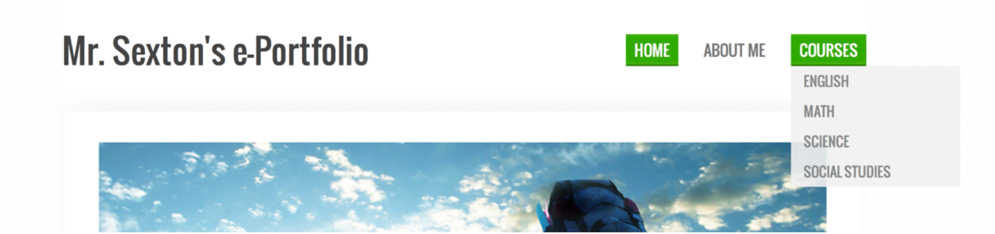

 | Mastered (x4) | Completed (x3) | Developing (x2) | Beginning (x1)
Artifacts (x3) | Material is used to clearly show a connection to goals that the students have given themselves. Students use a number of different kinds of artifacts to show that growth is occurring. | Material is used to clearly show a connection to goals that the students have given themselves. Students use a limited number of different kinds of artifacts to show that growth is occurring. | Material that is used to show a connection to goals that the students have given themselves is unclear. Students use a limited number of different kinds of artifacts to show that growth is occurring. | Material shows little to no connection to goals that the students have given themselves. Students use only one kind of artifact to show that growth is occurring.
Reflections (x3) | Each artifact is accompanied by a reflection that clearly explains the connections to your goals. Includes title, author, and date. | Most artifacts are accompanied by a reflection that clearly explains the connections to your goals. Includes title, author, and date. | Some artifacts are accompanied by a reflection that clearly explains the connections to your goals. Includes title, author, and date. | No artifacts are accompanied by a reflection that clearly explains the connections to your goals. Includes title, author, and date.
Goals (x2) | Goals are clearly labeled, achievable, found at the top of the class page, and are in regards to your desired outcome from the class. Lifelong goals are also clearly stated in the ‘about me’. | Goals are labeled, achievable, found at the top of the class page, and are in regards to your desired outcome from the class. Lifelong goals are also stated in the ‘about me’. | Goals are difficult to understand, may have issues achieving, found at the top of the class page, and are in regards to your desired outcome from the class. Lifelong goals are also lacking substance and found in the ‘about me’. | Course goals are not defined, achievable, or found at the top of the class page. Lifelong goals are difficult to find, and are lacking substance.
Multimedia (x2) | All of the multimedia enhance the purpose of the e-portfolio, create interest, and are appropriate. The content of the e-portfolio is enhanced in an original way. All of the examples are appropriate for the chosen purpose. | Most of the multimedia enhance the purpose of the e-portfolio, create interest, and are generally appropriate. The content of the e-portfolio is enhanced somewhat in an original way. | A few of the multimedia enhance the purpose of the e-portfolio, create interest, and are sometimes appropriate. The content of the e-portfolio is not always enhanced because of the inappropriate examples chosen for the purpose. | The photographs, graphics, sounds, and/or videos are inappropriate. They are distracting and detract from the content.
About me | Student has a comprehensive autobiography that describes the students’ history, and there is a link to a resume. | Student has an autobiography that briefly describes the students’ history, and there is a link to a resume. | Student has a substandard autobiography that lacks an understanding of the students’ history, and there is a link to a resume. | Student has a short autobiography that barely describes the students’ history, and there is no link to a resume.
Theme | The e-portfolio is easy to read. Fonts, point size, bullets, italics, bold, and indentations for headings and sub-headings enhance the presentation. Horizontal and vertical white space is always used appropriately. Background and colors enhance the readability and aesthetic quality of the text. | The e-portfolio is generally easy to read. Fonts, point size, bullets, italics, bold, and indentations for headings and sub-headings enhance the presentation. A few minor format changes would enhance the presentation. Horizontal and vertical white space is used appropriately in most places. Background and colors generally enhance the readability of the text. | The e-portfolio is often difficult to read. Fonts, point size, bullets, italics, bold, and indentations for headings and sub-headings do not always enhance the presentation. Some formatting tools are under or over-utilized. Horizontal and vertical white space is used inappropriately in some places. Background and colors are distracting in some places. They diminish somewhat the readability of the text. | The e-portfolio is difficult to read. Fonts, point size, bullets, italics, bold, and indentations for headings and sub-headings do not enhance the presentation. Many formatting tools are under or over-utilized. Horizontal and vertical white space is used inappropriately so that the content appears cluttered. Background and colors are distracting. They diminish the readability of the text.
Course Summary | Following the completion of a class the student will post an article that clearly connects that student’s course goals to the student’s understanding in that class. Explaining what areas were strong points and what areas were weak points. | Following the completion of a class the student will post an article that connects that student’s course goals to the student’s understanding in that class. Explaining what areas were strong points and what areas were weak points. | Following the completion of a class the student will post an article that somewhat connects that student’s course goals to the student’s understanding in that class. The student does moderate work explaining what areas were strong points and what areas were weak points. | Following the completion of a class the student will post an article that attempts to connect that student’s course goals to the student’s understanding in that class. Explaining what areas were strong points and what areas were weak points.
Spelling and Grammar | There are few errors in grammar, capitalization, punctuation, and spelling. | There are noticeable errors in grammar, capitalization, punctuation, and spelling. These require minor editing and revision. | There are a large number of errors in grammar, capitalization, punctuation, and spelling requiring editing and revision. | The text is difficult to understand because of errors in grammar, capitalization, punctuation, and spelling. It requires major editing and revision.

